Application of Multiple Sequence Alignment Profiles to Improve Protein Secondary Structure Prediction
James A. Cuff, Geoffrey J. Barton
Proteins: Structure, Function, and Genetics, Issue 40, pp.502-511, 2000
Abstract
In this article, we systematically investigate the effect of presenting alternative representations of the aligned sequences to a new two-level neural network algorithm similar to that applied in PHD.
- Method
- The final neural neywork method incorporated into the Jnet method
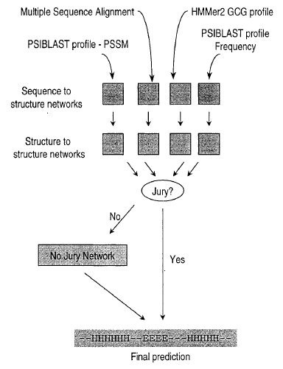

- The progress method to align distantly related proteins from a profile based search

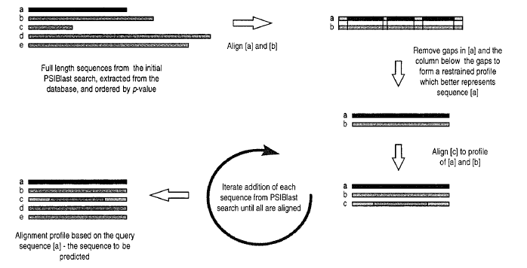
2. Example
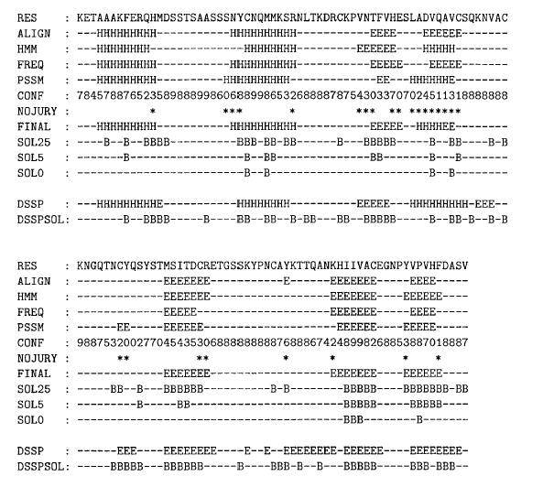
Created by: Hung-Wei Huang
Date: Apr. 30, 2003

